1. **Introduction**

Our project is called Instrument Map, which is a software for instrument users and instrument stores. By name, you can know that it can present the instrument store on a map, allowing consumers to better find the location of their favorite instrument and navigate to the desired store through the software. And this software is a great platform for store owners to showcase their stores. Because when users open the software, they can see what kind of instrument stores are around them, and after clicking on each store, they can see the details of the products inside.

Our software uses Baidu Maps API to provide users with reasonable and complete navigation routes, so that they can find their favorite stores more quickly and conveniently. This software is committed to providing better and higher quality services to various users, making the instrument purchase process smoother. Moreover, through the use of this software, the musical instrument industry can take advantage of the fast speed of the Internet and develop more rapidly.

1. **Requirements Specification**

This section is mainly divided into two small parts, namely user requirements and functional requirements. Firstly, user requirements mainly introduce the hopes that each user has for our application, while functional requirements are the functions that developers need to implement to fulfill user requirements.

Users Requirement

Through our investigation and analysis, it is concluded that the user's needs are mainly focused on the following four points. Firstly, users need the application to respond quickly in order to achieve a better user experience. Secondly, positioning accuracy is also important, as it will affect users' future purchases of musical instruments. Then, affordable prices are also what users need, and they place great importance on cost-effectiveness when purchasing musical instruments. Finally, there is the diversity of stores, and users hope to see more different instrument stores on the map for them to choose from.

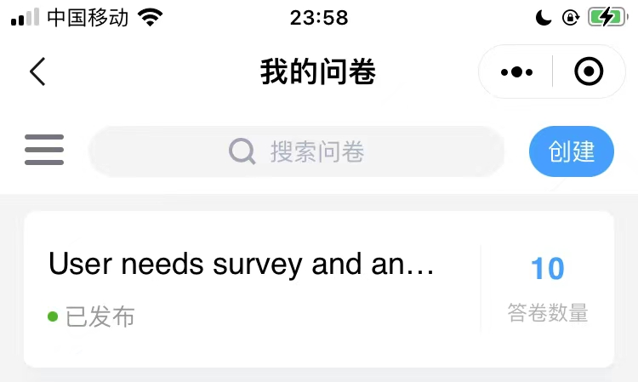

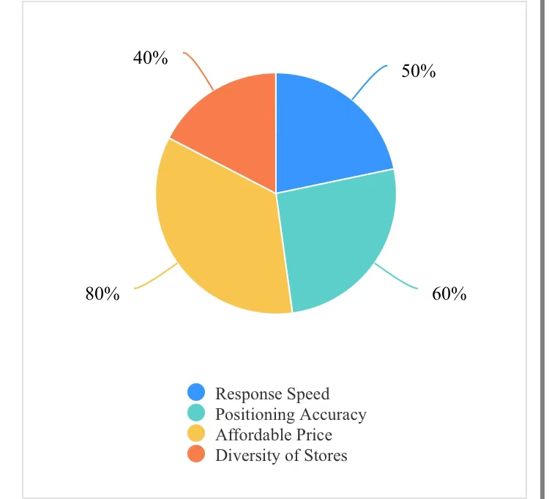

·response speed

Response speed is an important indicator for evaluating the smoothness of a software. The page's jump time should not exceed 1 second, and the response speed of key buttons should not exceed 0.5 seconds, which is the desired response speed for users.

·Positioning accuracy

Our application is a mapping software, so users hope that we can provide accurate positioning so that they can better find the location of the store.

·Affordable price

Our software provides the function of purchasing musical instruments, and the majority of users are musical instrument buyers. So it is also very reasonable for them to pay attention to the price when shopping.

·Diversity of stores

There are many users of our application who are not single instrument users, and they hope to see more different stores, so that they can have a chance to compare.

Functional Requirement

The following three requirements are the requirements we have made for developers during the development process, which are to ensure the priority of functions and ensure a clear order of use between various functions. Secondly, it is to ensure the smoothness of software usage, so that users have a good experience when using the software. Finally, it is necessary to ensure the stability of software usage, so that users can obtain a more stable environment when using the software.

·Ensure priority of functionality

The software we design will have many different functions, and there needs to be a clear sequence between functions, otherwise it will lead to a chaotic situation.

·Ensure smooth software usage

If the application can be used smoothly, it can provide users with a better user experience, thereby making them more inclined to use our application.

·Ensure the stability of software usage

Due to our application being a mapping software, there may be situations where users need to use it for a long time, such as during navigation, so stability is crucial, otherwise it may be interrupted during navigation.

1. **Overall Design**

Our software design is based on user needs and functional requirements, with a clear structure and various basic functions. It is basically a relatively complete application and can be used normally.

Structure

Due to limitations in development time and technology, we have only completed the front-end of the software, while the back-end is currently in the process of continuous development. Our front-end is written in Kotlin language, and in the login and registration interfaces, we connect to the database to store the user's username and password. For various reasons, we did not design an overly complex structure for the application. Its core technology is the connection with Baidu Maps API.

And our front-end can basically meet the functions of users' login registration and querying instrument stores. The backend is being designed to meet the needs of merchants, and it is expected to create an application similar to Taobao, allowing merchants to update store and product information on it.

Primary Function

Our software mainly has three functions. Firstly, the login and registration function allows each user to have their own independent account. Secondly, searching for store locations is one of our core functions, which can provide better services to users. Finally, navigate to the store, which is also a very core function that allows users to get to the location of the store.

·Login Registration

The login registration interface and welcome interface are integrated, where users can log in to their own unique account. If they do not have an account, they can obtain a brand new one by registering.

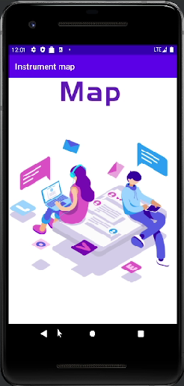

·Find store location

This is one of the core functions of our application. Through the search bar above the application, users can find their favorite store or product, and then click on the corresponding location to find their location on the map.

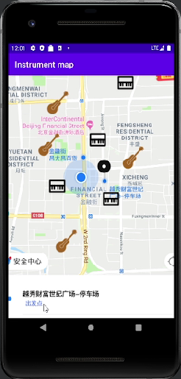

·Navigate to the store

When clicking on the detailed information interface of the store, we can see more information about the store and find the navigation button. After clicking the navigation button, we can see the specific route on the map.

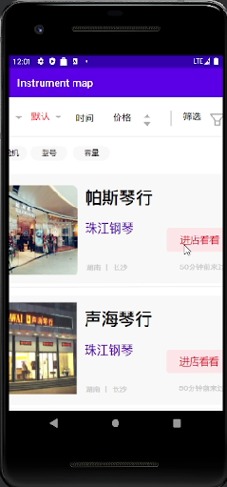

1. **User Interfere Design**

The design of the user interface is very important, as the user interface that users are most exposed to is the one on their phone screen. Firstly, the choice of color scheme is very important. We chose purple as the main color on the page because it is eye-catching and does not give people a particularly stimulating feeling. Next is the layout, where we choose to enlarge the icons and images to enhance users' grasp of key information. Finally, we try our best to improve the response speed so that users can have the best user experience.

·Color matching

In terms of color matching, we have chosen purple as the main color tone, while the background color is light gray, and each module is dark gray, which can give people a sense of hierarchy.

·layout

In terms of layout, we choose to highlight icons and images so that users can quickly find what they want. Moreover, the enlarged pictures of Traditional Japanese musical instruments and musical instruments can also let users see more details.

·response speed

Response speed is also a very important thing in the user interface. We will try to improve the response speed of the user interface as much as possible, so that the interface jump time does not exceed 1 second, and the key button response time does not exceed 0.5 seconds, in order to provide users with a better user experience.

1. **Key Technologies:**

1.User Interface Design: A shopping application needs a user-friendly and attractive interface. Android Studio provides a wealth of UI design tools and layout managers, such as XML layout files, ConstraintLayout, RecyclerView, etc., for creating the user interface of the application.

2.Data storage and management: Shopping applications usually need to process a large amount of product data, user information, order information, etc. You can use the data storage options provided by Android, such as SQLite databases, SharedPreferences, or use cloud services such as Firebase to store and manage this data.

3.User authentication and authorization: Shopping applications may require user registration, login, and authentication capabilities, as well as rights management to authorize users to access specific functions or sensitive information. You can use technologies such as Firebase Authentication, OAuth, etc. to achieve these functions.

4.Product display and search: Shopping applications need to display product lists, product details, product images, etc. You can use view components such as RecyclerView and GridView to display product lists, and use search functionality to help users find and filter products.

5.Location and geographic services: Shopping apps may need to obtain the user's geographic location information in order to provide location-based services, such as displaying nearby stores, calculating delivery distances, and so on. You can use Android's Location Services API to obtain the user's location, and use the Geocoding and Maps APIs to implement related functions.

6.BAIDU Maps API: BaiDu Maps API is a development interface that provides functions related to maps and geographic locations. It allows developers to display maps, mark locations, get user locations, calculate routes, and more in their applications. In Android Studio, you need to use the Google Maps API to integrate map functionality into your application.

7.Location Services (Location Services): Android provides a set of APIs for obtaining the location information of the device. You can use these APIs to get the user's current location, listen for location changes, get the status of location providers (such as GPS or network), etc. This is very important for map applications, because it allows you to mark the user's location on the map, provide navigation functions, and so on.

8.GPS positioning: GPS positioning is a technology that obtains the exact geographic location of a device through the Global Positioning System (GPS). In the map application, you can use the GPS positioning function of Android to obtain the real-time location of the user, so as to provide accurate navigation, route planning and other functions.

9.Geocoding: Geocoding is the process of converting a geographic location, such as an address, into latitude and longitude coordinates. In a mapping application, you might need to convert a user-supplied address into geographic coordinates for marking or navigating on a map. Android provides a geocoding API that can help you do this.

16.Routing: Routing is the process of calculating the best route between two or more locations. In a Maps application, you can use routing technology to help users find the shortest route, the fastest route, or a route that avoids congestion, etc. The Google Maps API provides a routing function that can help you calculate and display routes.

11.Map markers and interaction: Mapping applications often need to mark a specific location on the map, display an info window for the marker, and allow the user to interact with the map (such as zooming, dragging, etc.). Android Studio provides a wealth of APIs and tools for adding markers on the map, customizing marker styles, handling interactive events, and more.

1. Data storage and caching: Map applications usually need to process large amounts of geographic data, such as map tiles, location information, and so on. You need to consider how to store and manage this data efficiently so that maps can be loaded and displayed quickly in your application. Android provides a variety of data storage options, such as SQLite database, SharedPreferences, etc., which can help you with data management and caching.
2. **Tesing and User** **Experience Analysis**

We invited a total of 16 students to use the first version of our musical instrument map App. In order to collect their feedback, we also made relevant questionnaires. There are three questions in the questionnaire, which respectively ask the user's purpose, experience and feedback:

**6.1 Testing on the third-party cloud platform——WETEST**

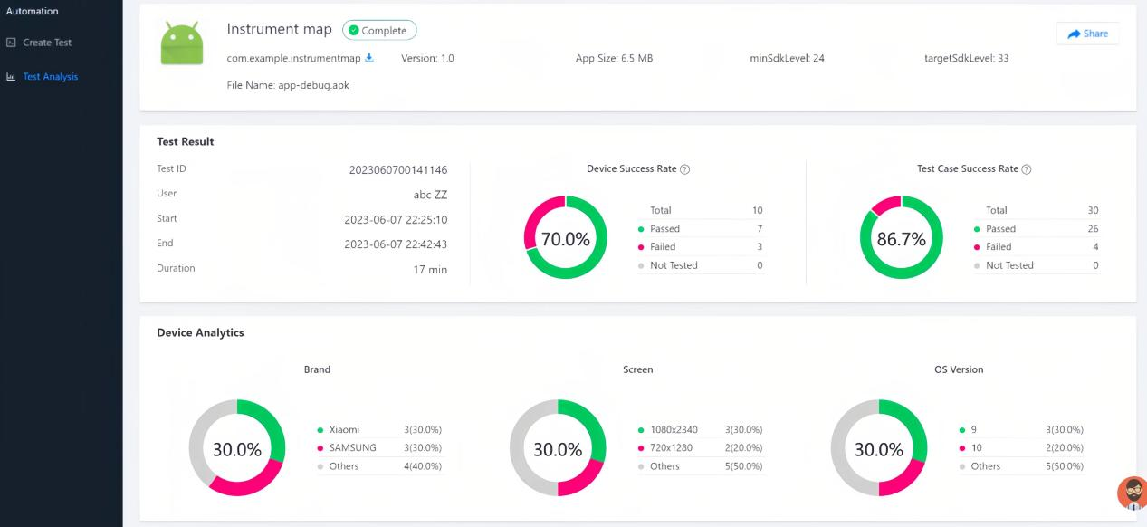

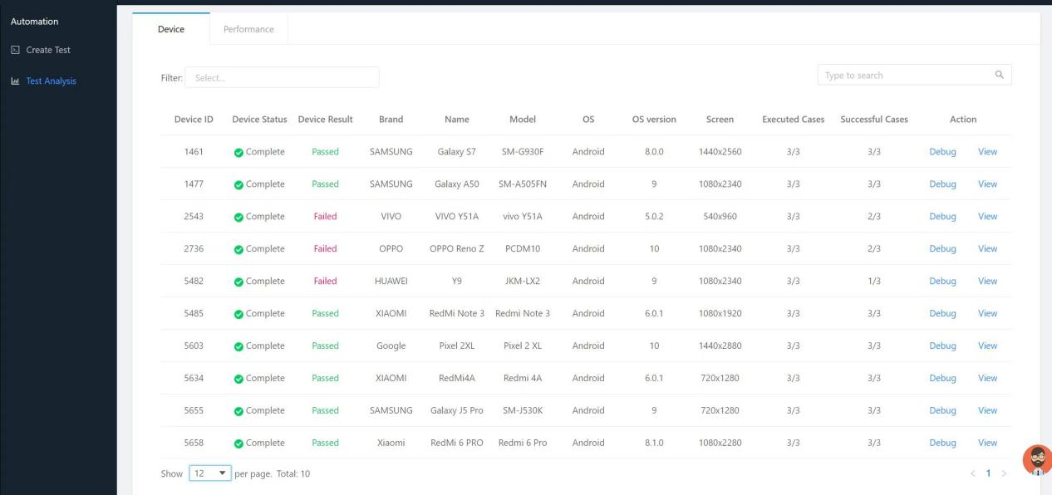

**6.2User Purpose**

Half of the students use our App to search musical instrument purchase channels, and a quarter of the students use musical instrument maps to find musical instrument storage resources and inquire musical instrument price information, and there is no other purpose.

These three are the main content of our App. Perhaps because these students do not have navigation needs, they do not have the function of using navigation to find the music shop.

The specific results are as follows:

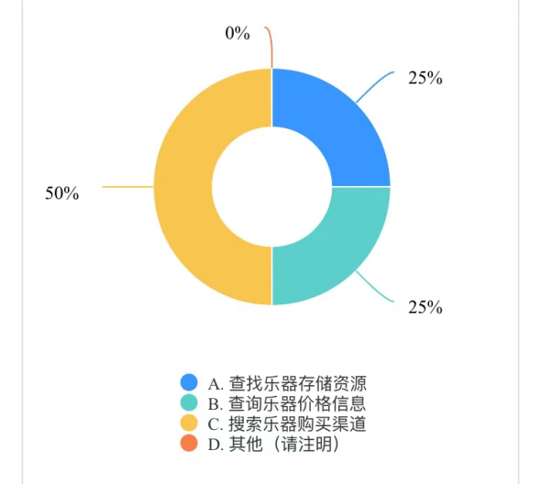

**6.3 User Experience**

We set up five gradient options: Very good, good, fair, poor, and very poor. Not every option is chosen, however. The students' comments focused on two options: three-quarters of the students thought the experience of using the instrument map was good, and a quarter of the students thought the experience was mediocre.

Very good, poor and very poor no one has a choice.

Therefore, the musical instrument map is still mostly positive. The specific results are as follows:

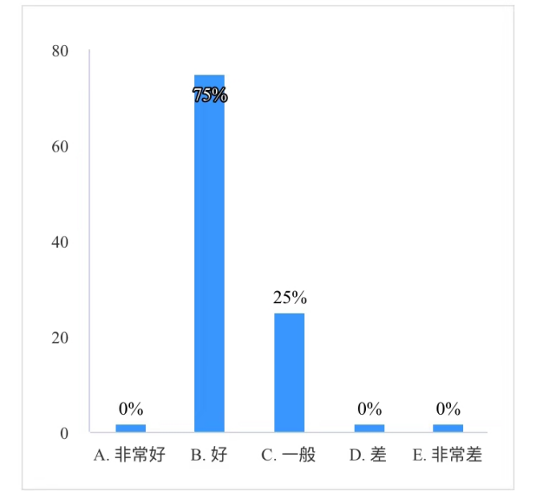

**6.4 User feedback**

A total of 7 students gave their opinions. The comments mainly focus on three aspects, one is the UI design (not sufficient), the second is the function (not rich enough), and the third is the information (slightly missing).

Specific results are as follows:

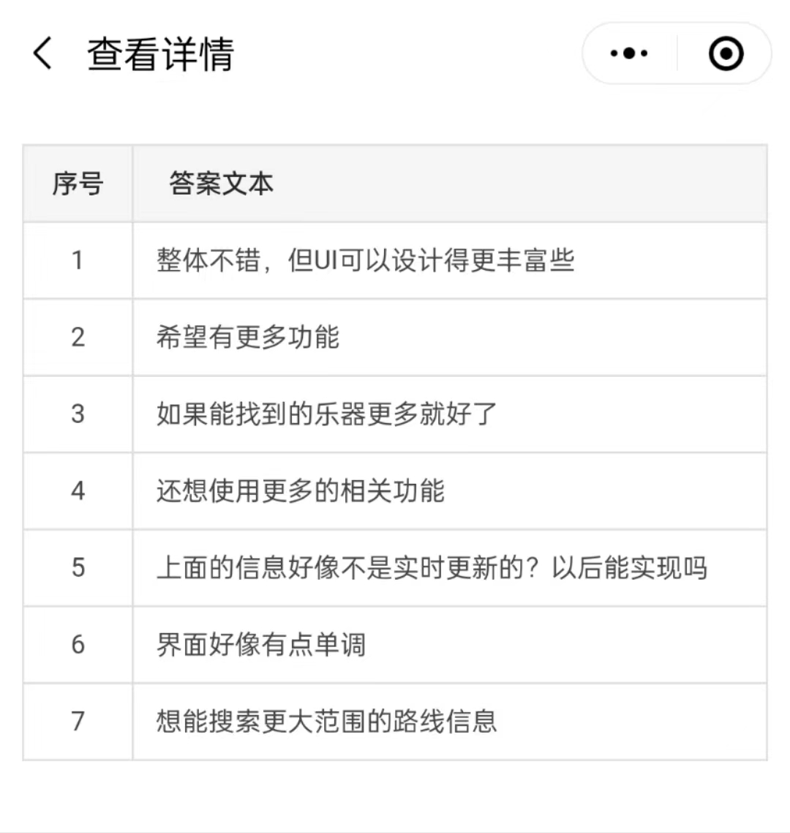

**6.5 Development Policy**

In response to the above problems, we have prepared corresponding development guidelines.

① Optimize the UI, enrich the interface with more patterns and colors

② Add more functions, such as: booking Musical Instruments, online contact shops and so on

③ Expand the business scope, obtain the authorization of the store, synchronize the musical instrument information with the offline line, and configure the sale of musical instrument by-products

④ More communication and exchange with users

⑤ Learn from the best software

1. **Conclusion**

**7.1 Summary**

In this course design, in order to solve the problem that it is difficult to find desired products and emergency products offline, and to fill the needs of the general public for purchasing offline Musical Instruments under specific circumstances, our ninth group of three members has carried out product information integration and store visualization, and combined offline users with the physical musical instrument industry. Developed a multifunctional instrument map App with Android Studio for finding music shops and instruments, locating and navigating to stores. The App can search for music shops and instruments, check store location and instrument prices, and use the navigation function to reach the store.

The App works perfectly and has been tested. The test results show that it works on most brands of mobile phones.

We also invited 16 students to use it for the first time, and they also gave relevant feedback through the questionnaire we made, indicating the future development direction for us.

After collecting all the information, we wrote the report together.

Although we encountered some difficulties and some contents were slightly inadequate, on the whole, we completed the task very successfully - but the core App functions were fully realized, and the testing, user feedback and reports were completed very well, which was a perfect cooperation.

**7.2 Achievements**

**7.2.1 Implementation of App**

As shown by our report in class, video demonstration and actual operation, we have indeed completed the functions that the instrument map written in our proposal report can achieve:

(1) Search for music shops and instruments

(2) After the search results are displayed, select the store to view the details

(3) Locate and navigate to the store

All of this is possible with Android Studio.

**7.2.2 Successful Test**

Our test went well. The test results show that the Instrument Map App works successfully on most devices.

The specific results are as follows:



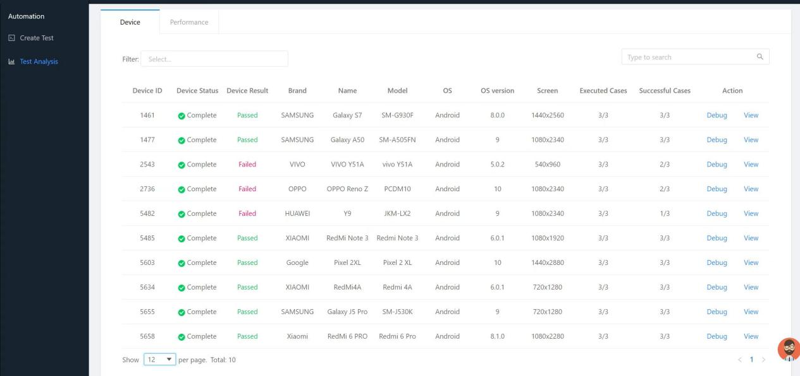

**7.2.3 Completion of Writing Work**

The writing work mainly includes two contents: one is to make the user questionnaire and publish and summarize the survey results; the other is to write the group English report, the business plan and the individual Chinese report respectively.

The work related to the questionnaire was carried out smoothly, as shown in **User Experience Analysis**.

In the case of the report, the group report is completed by everyone after division of labor and consultation. Specific tasks such as writing Outlines and details, integration, checking, and uploading all come to an end.

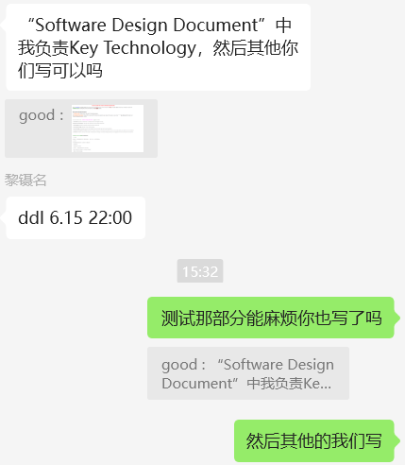

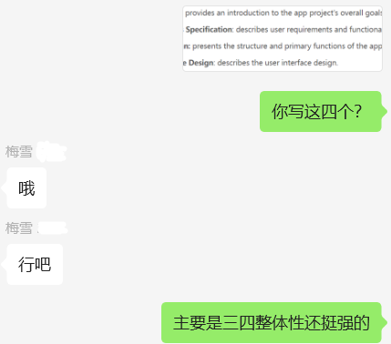

**7.2.4 The Ends of Tasks**

All the work was completed before the deadline. We went over and over again to make sure everything, including the code, powerpoint and reports, was wrong. If there is a problem, we can discuss the revision together. Finally, it was done at the last minute.

**7.2.5 Enhancement of Members' Affection**

Through this group cooperation, we all know each other better and take a step forward in friendship. The later we get, the more efficient we will be at accomplishing our tasks. The tone and atmosphere of our conversations in the wechat group have become more relaxed and easygoing.

We hope our relationship will last.

**7.3 Challenges**

**7.3.1 Communication**

Since we were not very familiar with each other at the beginning, our communication was rather formal. Sometimes we have different ideas, but it is difficult to express them well. Although most of the time we can understand each other's ideas, there are always times when we can not quite understand. For example, if one person wants to change the design and display of the App, the other person can't understand how she wants to change it.

Later, we all slowly tried to speak more and express ourselves more clearly; In the face of other people's questions do not escape, step by step to explain their own meaning, until everyone can understand, then put it into practice.

**7.3.2 Time**

As team members, we all come from different classes, which makes the time of each of our tasks overlap less and we have fewer opportunities to work in sync. And we're basically communicating online, which can lead to delays.

However, after realizing the problem, we all intentionally adjusted our schedules to suit others, and the rapidity and speed between us also improved.

If there are such homework in the future, I hope all the members of the team can contact more offline and have more real-time thinking collisions.

**7.3.3 Technology**

In the process of developing an App, we sometimes come across problems that three people can't solve. These problems are usually thrown out by one person, and then three people work together to find information, come up with ideas, and ultimately find no solution.

These problems may be that a certain page of the App does not know what technology is designed, it may also be running problems, or how to change the key place can not be changed...

At such times, we have no choice but to take a different path, use other methods to bypass the problem, and continue with the next task.

**7.4 Suggestions for Future Improvements**

At present, according to user feedback, our App still has some shortcomings. It mainly focuses on three aspects, one is that the UI design is not sufficient, the second is not rich enough functions, and the third is a slight lack of information.

Therefore, we have decided:

① Run your own App more, find out what can be improved, and record it

② All people find information together, hands-on practice, think about how to use different technologies to effectively solve the problem

③ After completion by ourselves to use a few more times

④ Open for students to use

⑤ Collect opinions and carry out circular improvement

**7.5 Solutions**

For the existing problems in the App, we have prepared corresponding solutions.

① Optimize the UI, make the layout more vivid, and design more patterns and colors to enrich the interface

② Add more functions and interfaces, improve switching between interfaces, such as: booking Musical Instruments, online contact shops, etc

③ Expand the geographical and functional scope of the business, so that the map is wider and can be applied to more areas

④ Set up more online customer service, communicate with users enough, collect and feedback problems in time

⑤ Refer to the forming software on the market, and apply its technology to the App

⑥ Maintain App operation to make it more smooth